## Reports/ Rx Reports/ XDEA Number Report

Request:

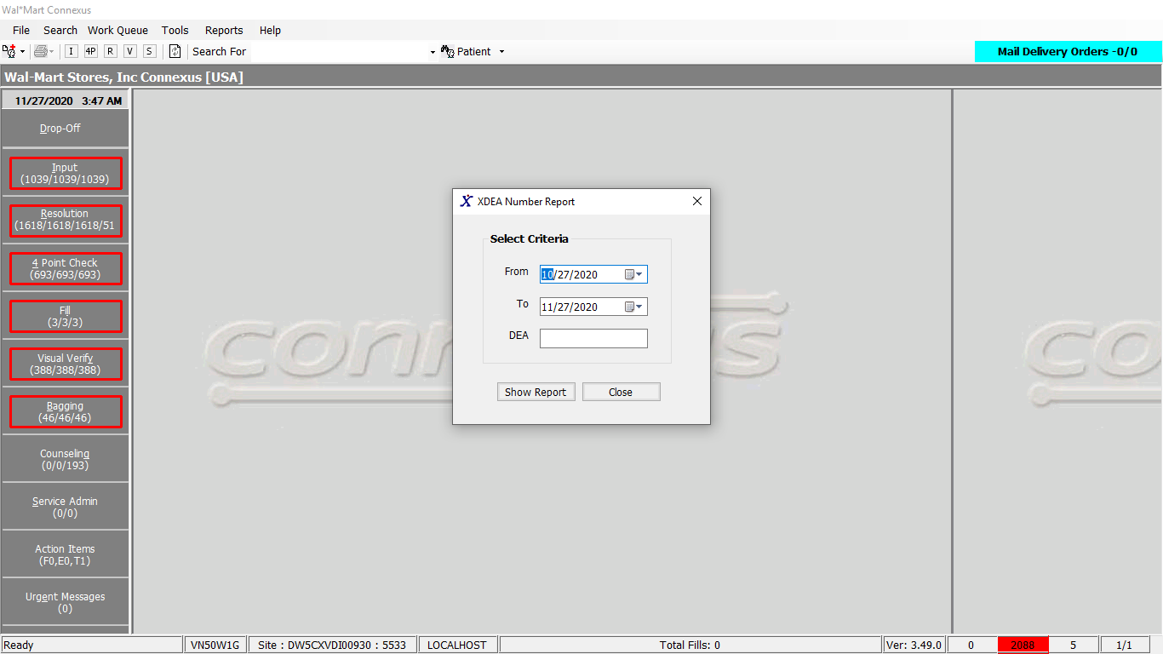

Response:

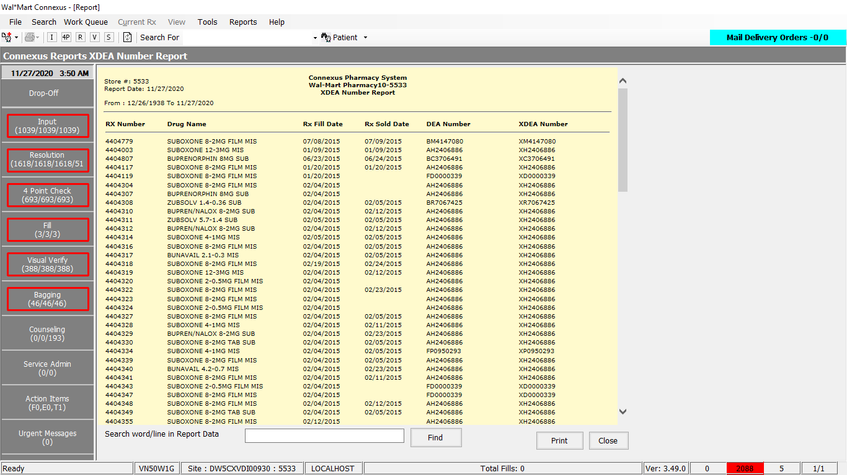

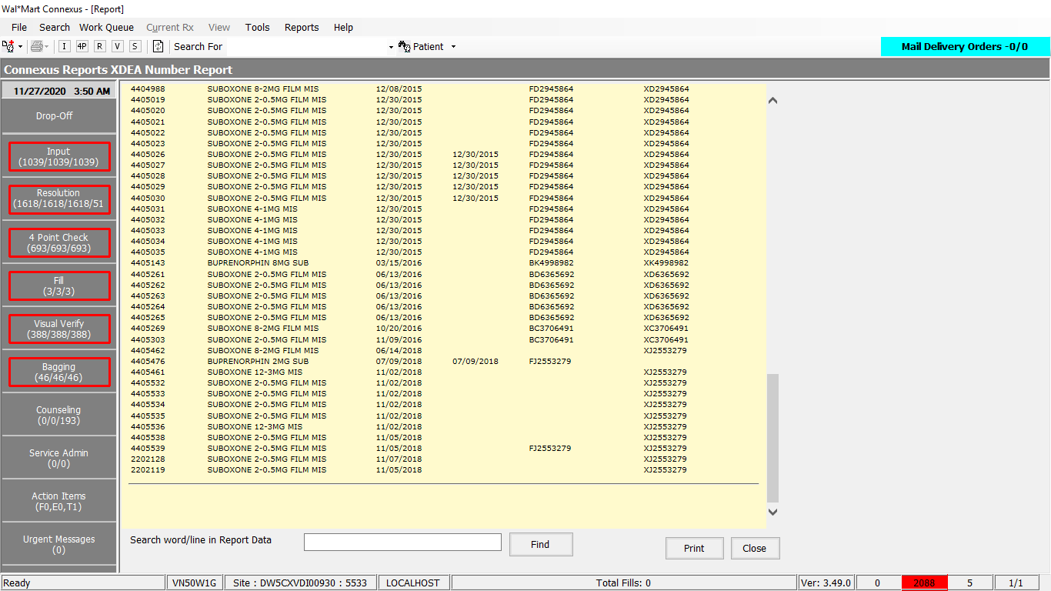

Queries:

Friend Const GetXDEANumberReportData As String = "SELECT rx.rx_nbr rx_nbr,pp.short_name drug_name,rf.fill_date rx_fill_date,rf.pos_ts rx_sold_date, " &

" CASE WHEN rfa.activity_code = 15116 THEN NULL ELSE rpl1.license_nbr END DEA, " &

" CASE WHEN rfa.activity_code = 15115 THEN null ELSE rpl2.license_nbr END XDEA " &

"FROM rx rx,rx_fill rf,pharmacy_offering:pharmacy_product pp, rx_prsbr_license rpl1, rx_prsbr_license rpl2 " &

",OUTER rx_fill_activity rfa " &

"WHERE rx.rx_nbr IS NOT NULL " &

"AND rx.rx_id = rf.rx_id " &

"AND rx.product_mds_fam_id=pp.product_mds_fam_id " &

"AND rpl1.license_nbr IS NOT NULL " &

"AND rpl2.license_nbr IS NOT NULL " &

"AND rx.rx_id = rpl1.rx_id " &

"AND rx.rx_id = rpl2.rx_id " &

"AND rpl1.license_type_code in( 800,801,802,808) " &

"AND rpl1.license_nbr NOT LIKE 'X%' " &

"AND rpl2.license_nbr LIKE 'X%' " &

"AND rpl2.prescriber_id = rpl1.prescriber_id " &

"AND rpl1.license_nbr <> rpl2.license_nbr " &

"AND rf.rx_fill_id = (SELECT MIN(rf1.rx_fill_id) " &

"FROM rx_fill rf1 WHERE rf1.rx_id = rf.rx_id " &

" AND rf1.status_code IN(20401,20404,20407,20408)) " &

" AND rf.rx_fill_id = rfa.rx_fill_id " &

" AND rfa.activity_code in (15115,15116) " &

"AND rf.fill_date BETWEEN ? AND ? "

DAL:

Public Function GetXDEANumberReportData(ByVal siteId As Integer,

ByVal XDEANumberReportDataInputInfoBE As _

GetXDEANumberReportDataInputInfoBE) _

As List(Of GetXDEANumberReportDataInfoBE) Implements IReportDAL.GetXDEANumberReportData

Using (New Tracer(ConnexusCommonConstants.ConnexusTracer))

Dim xdeaRptQuery As New StringBuilder()

Dim xdeaNumberReportDataInfoBEList As New List(Of GetXDEANumberReportDataInfoBE)

Dim paramList As New List(Of DbParameter)

paramList.Add(ParameterHelper.BuildParameter("FromDate", DbType.Date, XDEANumberReportDataInputInfoBE.FromDate))

paramList.Add(ParameterHelper.BuildParameter("ToDate", DbType.Date, XDEANumberReportDataInputInfoBE.ToDate))

xdeaRptQuery.Append(ReportQueries.GetXDEANumberReportData)

If Not (String.IsNullOrEmpty(XDEANumberReportDataInputInfoBE.DEANbr)) Then

paramList.Add(ParameterHelper.BuildParameter("xdea", DbType.String, XDEANumberReportDataInputInfoBE.DEANbr.Trim()))

If (XDEANumberReportDataInputInfoBE.DEANbr.Trim().StartsWith("X")) Then

xdeaRptQuery.Append("AND rpl2.license_nbr = ? ")

Else

xdeaRptQuery.Append("AND rpl1.license_nbr = ? ")

End If

End If

Dim dataReader As IDataReader = ExecuteReader(DatabaseEnum.rx21c, siteId, xdeaRptQuery.ToString, paramList)

Dim getXDEANumberReportDataInfoBE As GetXDEANumberReportDataInfoBE

While dataReader.Read()

getXDEANumberReportDataInfoBE = New GetXDEANumberReportDataInfoBE

If Not dataReader.IsDBNull(dataReader.GetOrdinal("rx_nbr")) Then

getXDEANumberReportDataInfoBE.RxNbr = CInt(dataReader("rx_nbr"))

End If

If Not dataReader.IsDBNull(dataReader.GetOrdinal("drug_name")) Then

getXDEANumberReportDataInfoBE.DrugName = CStr(dataReader("drug_name")).Trim

End If

If Not dataReader.IsDBNull(dataReader.GetOrdinal("rx_fill_date")) Then

getXDEANumberReportDataInfoBE.FillDate = CDate(dataReader("rx_fill_date"))

End If

If Not dataReader.IsDBNull(dataReader.GetOrdinal("rx_sold_date")) Then

getXDEANumberReportDataInfoBE.SoldDate = CDate(dataReader("rx_sold_date"))

End If

If Not dataReader.IsDBNull(dataReader.GetOrdinal("DEA")) Then

getXDEANumberReportDataInfoBE.DEA = CStr(dataReader("DEA")).Trim

End If

If Not dataReader.IsDBNull(dataReader.GetOrdinal("XDEA")) Then

getXDEANumberReportDataInfoBE.XDEA = CStr(dataReader("XDEA")).Trim

End If

xdeaNumberReportDataInfoBEList.Add(getXDEANumberReportDataInfoBE)

End While

If xdeaNumberReportDataInfoBEList.HasRecords Then

Return xdeaNumberReportDataInfoBEList

Else

Return Nothing

End If

End Using

End Function